

NAME: AJAY KUMAR REDDY
REG NO:192425274
COURSE CODE: MLA0214
COURSE NAME: FUNDAMENTAL OF MACHINE LEARNING

QUESTION: Build an Artificial Neural Network by implementing the Backpropagation algorithm and test the same using appropriate data sets.
AIM: To implement the K-Nearest Neighbors algorithm for classification.
ALGORITHM:
Start the program.
- Define training data.
- Choose the value of K.
- Train the KNN model.
- Provide a new sample.
- Predict the class based on nearest neighbors.

CODE:
from sklearn.neighbors import KNeighborsClassifier
X = [[1],[2],[3],[6],[7],[8]]
y = ['A','A','A','B','B','B']
model = KNeighborsClassifier(n_neighbors=3)
model.fit(X,y)
print("Prediction for 5:",model.predict([[5]]))
OUTPUT:
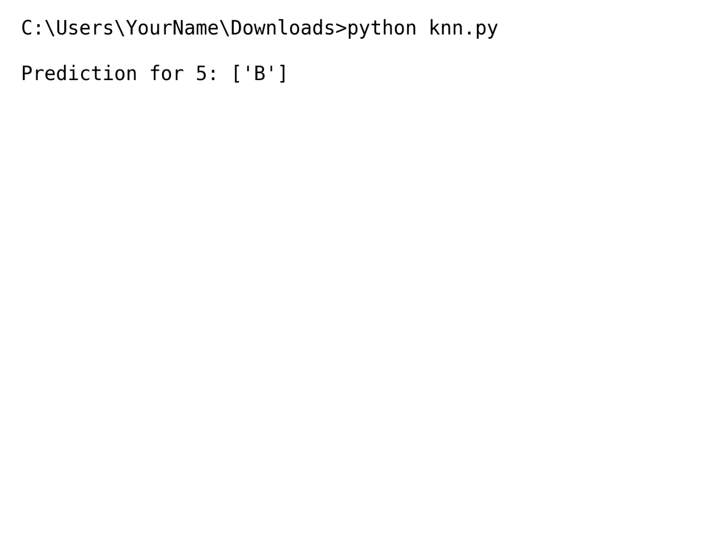
RESULT: The KNN algorithm successfully classifies the new sample based on nearest neighbors.

